## Rest template hack

Populate a map and send the map to the rest template

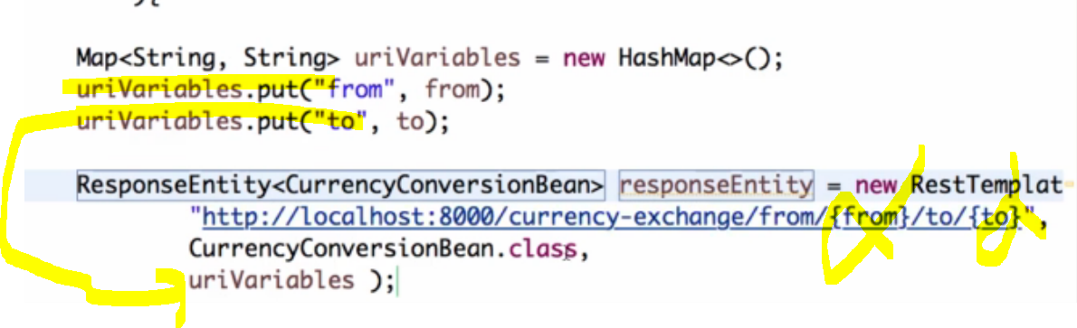

U can bind to a big decimal too

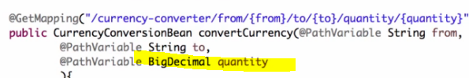

### Feign client

